*APPLICATIONS ACCEPTED ONE YEAR IN ADVANCE*

Dear WBCA Park Renter:

Thank you for your interest in renting the Warm Beach Community Association Park Facilities.

Following this cover letter are WBCA Park rental guidelines and other information you will find useful in preparing for your day in our park. Please read through all these materials before making your application.

Please complete, sign and date the application and attach your damage deposit and payment in full, and return it to: WBCA, PO Box 811, Stanwood, WA 98292. Acceptable forms of payment are cash, check (made out to WBCA), Visa, or MasterCard. If you wish to pay via credit card, there will be an additional processing fee. WBCA processes credit cards through PayPal. You may submit payment using this link: <https://www.paypal.me/wbcastanwood>.

We hope you have an enjoyable time in our beautiful park. If you have questions, contact us at [ParkInfo@warmbeachcommunityassoc.org](mailto:ParkInfo@warmbeachcommunityassoc.org).

WBCA Park Manager

PO Box 811

Stanwood WA 98292

## FACILITY USE GUIDE

## CHECKLIST for Renting the Warm Beach Community Association Park:

**Permits May be Required to Conduct Your Event**

**Definition of Event:**

* If the Park is used on a scheduled basis, it must be on the WBCA Park Calendar
* It is an Event if it has more than 20 people participating
* It is an Event if it limits the usage of the park or a portion of the park to event attendees
* It is an Event if any fees will be paid by attendees to participate
* Any Event scheduled must be on the WBCA Park Calendar
* An Event may require the oversight of the park manager

1. **Contact the Park Manager** at[ParkInfo@warmbeachcommunityassoc.org](mailto:ParkInfo@warmbeachcommunityassoc.org) to verify the date and park availability.
2. **Print the park rental packet**. It is available via email or regular mail from the WBCA or by downloading the forms from the WBCA website at [https://warmbeachcommunityassoc.org](https://warmbeachcommunityassoc.org/)[.](http://wbca-stanwood.blogspot.com/)
3. **Complete the application form** and return it by mail, or scan and email to [ParkInfo@warmbeachcommunityassoc.org](mailto:ParkInfo@warmbeachcommunityassoc.org).
4. **Full payment plus damage deposit** (see fee schedule)needs to accompany the application. We accept the following forms of payment: cash, check (Payable to WBCA), Visa, or M/C at <https://www.paypal.me/wbcastanwood> (see fee schedule for processing fees).
5. **Your application and paid fees will reserve your date in our WBCA Park Calendar.**
6. **Insurance is required to confirm your reservation:**
   1. Your next step is to secure your insurance and give the WBCA Park Manager a copy to **confirm your reservation**.
   2. You must secure a temporary insurance certificate naming WBCA as insured. Your personal liability insurance may offer you a temporary insurance certificate at little or no charge. You may purchase insurance through the WBCA insurance agent (Thomas & Associates-WAFD Insurance Group, 360-629-2103) or [www.eventhelper.com](http://www.eventhelper.com). WBCA requires a copy of your insurance certificate to confirm your reservation, and you must post a copy at the event.

**These Additional Permits May be Required to Conduct Your Event**

1. **If alcohol will be available** at your event, you will need to get a Banquet Permit from the WA State Liquor & Cannabis Board. You can apply online at: <https://lcb.wa.gov/licensing/online-banquet-permit>. You should allow 60 days to receive your permit. WBCA requires a copy of your permit 30 days before the event, and you must post a copy at the event.
2. **If you intend to sell alcohol or food**, your caterer or you will need to get the required permits (food service and/or liquor service). WBCA requires a copy of your permit(s) 30 days before the event, and you must post a copy at the event.
3. If you plan to “conduct or sponsor a special event or erect temporary tents or structures for a special event on public or private property, Snohomish County requires that you first get a **special event permit**, except a permit shall not be required for any special event with 49 or fewer participants or where no temporary tents or structures shall be erected.” (Snohomish County RCW 30.53A). This is a fire safety issue and is governed by the Snohomish County Fire Marshal’s office. To apply for a Special Event application visit <https://pdspermitportal.snoco.org/pdsportal/app/login> and download the form. You will also need to download the Special Event Permit Instructional Guide at <https://snohomishcountywa.gov/DocumentCenter/View/16562>. This application must be submitted to the county at least 60 days in advance of the event. WBCA requires a copy of your permit 30 days before the event, and you must post a copy at the event.

**WBCA PARK RENTAL AMENITIES & FEES**

**19016 94th Drive NW, Stanwood WA**

[**ParkInfo@warmbeachcommunityassoc.org**](mailto:ParkInfo@warmbeachcommunityassoc.org)

**360-218-4930**

|  |  |  |
| --- | --- | --- |
| **Amenities** | **Details** | **Fees** |
| Grassy Area | Approximately 1.65 acres of grass with a few trees and shrubs and 3 privately used outbuildings. | Included in rental fee |
| Covered Shelter | Concrete pad with cover and power; approx. 1,440 sq. ft. |
| Picnic Tables | 6 wooden picnic table/bench combinations |
| Stationary Steel BBQs | 2 free-standing, coal-burning units adjacent to covered shelter |
| Restrooms | 2 gender-neutral restrooms, one of which is ADA-compliant (handicapped accessible). |
| Children’s Play Area | Small play area with bark substrate |
| Fire Pit | A small fire-pit is located between the Covered shelter and the Children’s Play Area (Subject to then current Burn Ban conditions) |
| Parking Area | Gravel lot across the street from the park; approximately 0.8 acres suitable for parking. |
| Power | Available in Covered Shelter |  |
| Fire Extinguishers | Fire extinguishers are located at Food Shack and bathrooms. |  |
| Trash Receptacles | Renters may use our trash receptacles on request but must remove/dispose of their own garbage and BBQ coals or pay Trash Dump Fee. |  |
| Food Shack |  | N/A |
| Kitchen | Secure kitchen area with refrigerator, and sink; approximately 480 square feet. | N/A |
| Folding Tables | 32 six-foot folding tables | see below |
| Folding Chairs | 73 folding chairs | see below |
| Sink/water | Available in restrooms |  |
| Damage Deposit |  | see below |

**WBCA PARK RENTAL FEE SCHEDULE**

**Member Pricing Non-Member Pricing**

**Park Rental: $50/day* $200/day\***

**Food Shack $10/day $20/day**

**Tables and Chairs $25 $50**

**Damage Deposit $100 $250**

**Trash Dump Fee $50 $50**

**No fee if you dump your own trash**

**\*(rental payment required for set-up and take-down days)**

**Credit Card Processing fee is 2.96%**

**WBCA PARK RENTAL POLICIES & PROCEDURES**

[**ParkInfo@warmbeachcommunityassoc.org**](mailto:ParkInfo@warmbeachcommunityassoc.org)

**360-218-4930**

**Park rental hours are 8:00 a.m. to 9:00 p.m. on weekdays; 7:00 a.m. to 10:00 p.m. on weekends.**

**The park is on a residential street. Please observe the speed limit of 25 MPH and be respectful of neighbors.**

**WBCA Park rules & regulations are subject to change without notice by direction of the Board of Directors.**

**RESERVATIONS**

1. Once forms and fees are processed, a rental confirmation will be sent to the email address provided, which will also show payment received.
2. This reservation form authorizes the designated group to use the facility indicated. It is highly recommended that the person in charge have this form in their possession during the event.
3. CHANGING RESERVATIONS. If you need to change a reservation, please contact the Park Manager as soon as possible but no later than 14 days before the original date. We cannot guarantee that your new choice of date or time will be available.
4. CANCELLATION. Cancellations must be made via email or in writing, *14 business days in advance of the reservation date to be eligible for a refund.* There are no pro-rated or partial refunds. A refund will be processed in the same method as the payment was made. *No refunds will be issued on cancellations made less than 14 business days before the rental date.* The WBCA reserves the right to cancel this reservation if: 1) The applicant fails to provide the necessary paperwork and deposit by *30 days before the event*, or 2) the facilities become unavailable due to required maintenance or if the facilities become otherwise unusable. If the WBCA must cancel the reservation, the renter receives a full rental refund. No refunds will be issued for inclement weather.

**ALLOWED WITH APPROVAL**

1. Fires are allowed in stationary BBQs only, subject to Snohomish County burn ban restrictions.
2. Use of personal barbeque equipment outside of the shelter is subject to approval. No **additional** barbeques are allowed inside the picnic shelter. Do not dispose of hot coals in the park trash receptacles.
3. Amplified sound or music is allowed with approval from the WBCA. Unincorporated Snohomish County sound ordinances apply.
4. Alcoholic beverages are allowed in the park only with prior approval and a valid Banquet Permit or Liquor License on file and on display at the park.
5. Well-managed dogs are allowed if they are on a leash at all times. The owner (or handler) is required to clean up after the animal.
6. You may cover tables with cloths or paper. Please use tape to adhere any table covers. Do not use nails or staples on picnic or folding tables. DO NOT COOK ON TABLES.
7. You may use our trash receptacle(s) but you must supply your own garbage bags and remove all garbage upon vacating the park, clean tables and chairs or pay an additional fee.
8. The refrigerator is available with the kitchen rental. Please remove any of your items and wipe up any spills.
9. If you are using tents that require stakes, you must meet with the Park Manager to review where the tents may be placed due to the septic system. Otherwise, sandbags/weights may be used to anchor objects.

**PROHIBITED ACTIVITIES**

1. Trees, shrubs, ferns, plants, flowers, and any other natural habitat are not to be removed from the park.
2. There shall be no overnight camping, littering, disturbing of wildlife, removal or destruction of property.
3. No person shall post or attach any sign, poster, notice, or any other device of any kind for advertising in the park.
4. Do not climb on tables, trees, or fencing. Do not stand on chairs, tables, or benches.
5. Fireworks and firearms are prohibited.
6. Do not use hibachis and/or barbeques on the tabletops.
7. Smoking is prohibited on park grounds.
8. No vehicles are allowed in the park or along/on the public road and right-of-way. Park in the parking lot only.
9. The use of “Silly String,” “Bouncy Houses,” or other large inflatables is prohibited in the park.

|  |  |  |  |  |  |  |
| --- | --- | --- | --- | --- | --- | --- |
| **WBCA**  **Park Rental Application** | | | | | | |
| **Applicant Information** (Responsible Party) | | | | | | |
| Applicant/Organization: | | Primary Phone: | | | | |
| Main Contact: | | Secondary Phone: | | | | |
| Mailing Address: | | | | | | |
| City: | | | | | State: | Zip: |
| Email: | | | Day of Event Phone: | | | |
| **Event Information** | | | | | | |
| **Event set-up date/time:** | | | | | | |
| **Event Date:** (day of the week & date) | | | | **Time: to** | | |
| **Event set-up date/time:** | | | | | | |
| Describe general nature of event (i.e. wedding, family reunion, company picnic, etc.): | | | | | | |
| Attendance Expected:_______ | Special Event Permit Required?  ◻ Yes ◻ No | | | | | |
| Name of Caterer:  Phone number: | Alcohol Served? (If yes, a Banquet Permit or Liquor License is required) ◻ Yes ◻ No | | | | | |
| Will there be music? (If yes, provide description)  ◻ Yes ◻ No | Will there be a hired entertainer? (If yes, please provide description) ◻ Yes ◻ No | | | | | |
| **Note: If you intend to use amplified sound for your event, according to Snohomish County, the sound cannot be loud enough to be heard within any of the homes surrounding the park or outside at a distance of more than 75 feet from the sound generation.** | | | | | | |
| Facilities you plan to rent (check all that apply):  ◻ Park & Covered Area ◻ Kitchen ◻ Cook Shack | | | | | | |
| Equipment you plan to rent (check all that apply):  ◻ Tables/Number:____ (32 available) ◻ Chairs/Number: ____ (73 available) ◻ BBQs: ___(2 available) | | | | | | |

**AGREEMENTS**

The undersigned hereby makes application to WBCA for the use of their park facility described above and certifies that the information given in the application materials is correct. The undersigned further states that he/she has the authority to make this application for the applicant and agrees that the applicant will observe the rules, regulations, policies, and procedures of the WBCA. The applicant assumes responsibility for the conduct of his or her guests and/or contractors associated with or attending the event. The applicant agrees to exercise the utmost care in the use of the premises and property and to hold the WBCA harmless from all liability resulting from the use of said facilities. The applicant further agrees to reimburse the WBCA for any damage arising from the applicant’s use of said facilities. The applicant signing this agreement will be considered the responsible party in case of damage, theft, or disturbances during the rental period.

I have read, understood, and agree to comply with all procedures in the WBCA’s Facility Use Guide for the facility I am requesting to use. I further certify that I am 18 years of age or older.

**SIGNATURE (REQUIRED):** Main Contact: Date: __________

Intentionally Left Blank

These two pages will assist you in making the application to the County should you require a Special Event Permit.



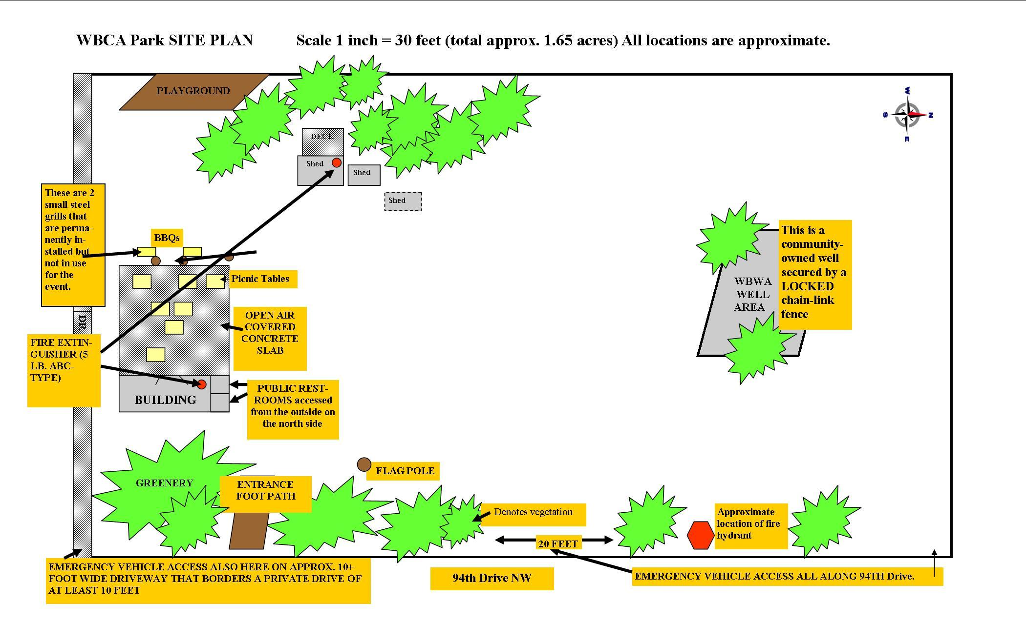



SnoPUD Well Area

SnoPUD



